**Exercise 1: Configuring a Basic Spring Application**

BookRepository.java

package com.library.repository;

public class BookRepository {

public void save(String bookName) {

System.out.println("Book saved: " + bookName);

}

}

BookService.java

Path: src/main/java/com/library/service/BookService.java

package com.library.service;

import com.library.repository.BookRepository;

public class BookService {

private BookRepository bookRepository;

public void setBookRepository(BookRepository bookRepository) {

this.bookRepository = bookRepository;

}

public void addBook(String bookName) {

System.out.println("Adding book: " + bookName);

bookRepository.save(bookName);

}

}

MainApp.java

package com.library;

import com.library.service.BookService;

import org.springframework.context.ApplicationContext;

import org.springframework.context.support.ClassPathXmlApplicationContext;

public class MainApp {

public static void main(String[] args) {

ApplicationContext context = new ClassPathXmlApplicationContext("applicationContext.xml");

BookService bookService = (BookService) context.getBean("bookService");

bookService.addBook("Spring in Action");

}

}

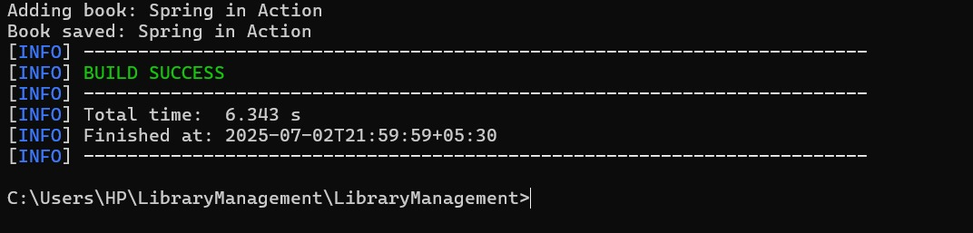

**Exercise 2: Implementing Dependency Injection**

public class Main {

interface Engine {

void start();

}

static class PetrolEngine implements Engine {

public void start() {

System.out.println("Petrol engine starting...");

}

}

static class DieselEngine implements Engine {

public void start() {

System.out.println("Diesel engine starting...");

}

}

static class Car {

private Engine engine;

public Car(Engine engine) {

this.engine = engine;

}

public void startCar() {

engine.start();

System.out.println("Car is running...");

}

}

public static void main(String[] args) {

Engine petrol = new PetrolEngine();

Car car1 = new Car(petrol);

car1.startCar();

Engine diesel = new DieselEngine();

Car car2 = new Car(diesel);

car2.startCar();

}

}

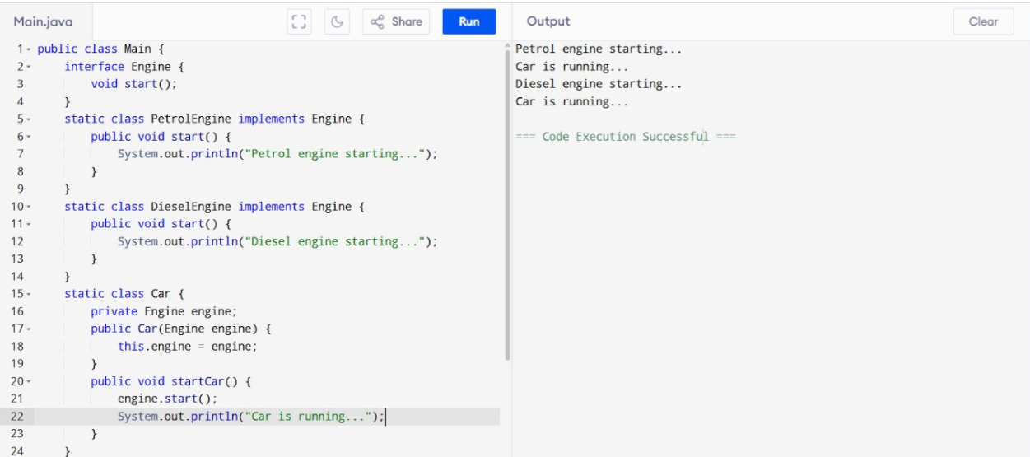

**Exercise 4: Creating and Configuring a Maven Project**

<project xmlns="http://maven.apache.org/POM/4.0.0" xmlns:xsi="http://www.w3.org/2001/XMLSchema-instance"

xsi:schemaLocation="http://maven.apache.org/POM/4.0.0 http://maven.apache.org/xsd/maven-4.0.0.xsd">

<modelVersion>4.0.0</modelVersion>

<groupId>GSSS_Maven_pgm2</groupId>

<artifactId>pgm2_maven</artifactId>

<version>0.0.1-SNAPSHOT</version>

<packaging>jar</packaging>

<name>pgm2_maven</name>

<url>http://maven.apache.org</url>

<properties>

<project.build.sourceEncoding>UTF-8</project.build.sourceEncoding>

<java.version>1.8</java.version>

</properties>

<dependencies>

<dependency>

<groupId>junit</groupId>

<artifactId>junit</artifactId>

<version>3.8.1</version>

<scope>test</scope>

</dependency>

<dependency>

<groupId>org.springframework.boot</groupId>

<artifactId>spring-boot-starter-parent</artifactId>

<version>2.2.1.RELEASE</version>

<type>pom</type>

</dependency>

<dependency>

<groupId>org.springframework.boot</groupId>

<artifactId>spring-boot-starter-web</artifactId>

<version>2.2.1.RELEASE</version>

</dependency>

</dependencies>

</project>

